**Term-work 4**

**Complete problem definition of the Term-work**

**Design** and **Implement** an APPLET for any computer game of your choice. Store the user name and the score of each game session in the database (MySQL).

**Expected Learning**: Applet life cycle, Java Database connectivity, events, AWT/SWING components, Application Design and Implementation. (May use Generics)

**Source code/Program**

/*

* To change this license header, choose License Headers in Project Properties.

* To change this template file, choose Tools | Templates

* and open the template in the editor.

*/

/**

*

* @author kishan

*/

import javax.swing.*;

import java.awt.*;

import java.awt.event.*;

import java.sql.*;

class DbConnect1 {

private Connection con;

private Statement st;

private ResultSet rs;

public DbConnect1() {

try{

Class.forName("com.mysql.jdbc.Driver");

String url = "jdbc:mysql://localhost:3306/game";

con = DriverManager.getConnection(url,"root","");

st = con.createStatement();

}catch(ClassNotFoundException | SQLException e) {

System.out.println("Error"+e);

}

}

public void getData() {

try{

String query = "select * from game_score" ;

rs = st.executeQuery(query);

System.out.println("Records of database");

while(rs.next()) {

int game_score = rs.getInt("score");

//String name = rs.getString("name");

//String dept = rs.getString("dept");

System.out.println("GAME SCORE: " +game_score);

}

}catch(SQLException e) {

System.out.println("Exception "+e);

}

}

public void insert_data(int score2) {

try{

String query1 = "insert into game_score(score)" + "values(?)";

PreparedStatement ps = con.prepareStatement(query1);

ps.setInt(1,score2);

ps.execute();

}catch(SQLException e) {

System.out.println("Exception "+e);

}

}

}

class game5 extends DbConnect1 implements ActionListener {

JFrame jf;

JLabel jl1, jl2, jl3;

JButton start,click,stop;

String msg = "";

String str;

int score1,score2;

game5() {

jl1 = new JLabel("Press start to start game");

jf = new JFrame("A Simple Game ");

jf.setLayout(new FlowLayout());

jf.setSize(500,100);

jf.setDefaultCloseOperation(JFrame.EXIT_ON_CLOSE);

jf.setVisible(true);

start = new JButton("Start");

click = new JButton("Click");

stop = new JButton("Stop");

jf.add(jl1);

jf.add(start);

start.addActionListener((ActionListener) this);

click.addActionListener((ActionListener) this);

stop.addActionListener((ActionListener) this);

}

@Override

public void actionPerformed(ActionEvent ae) {

str = ae.getActionCommand();

if(str.equals("Start")) {

start.setVisible(false);

jl1.setVisible(false);

jl2 = new JLabel("Press click to increase score");

jl3 = new JLabel("Press stop to stop the game");

jf.add(jl2);

jf.add(click);

jf.add(jl3);

jf.add(stop);

}

if(str.equals("Click")) {

score1++;

//System.out.println(score1);

}

if(str.equals("Stop")) {

int score = score1;

DbConnect1 connect = new DbConnect1();

connect.insert_data(score);

connect.getData();

System.exit(0);

}

}

}

public class game extends game5 {

public static void main(String args []){

SwingUtilities.invokeLater(new Runnable() {

public void run() {

game5 g = new game5();

//System.out.println(g.score2);

}

});

}

}

**OUTPUT WITH SCREENSHOT**

//A simple game screen with start button

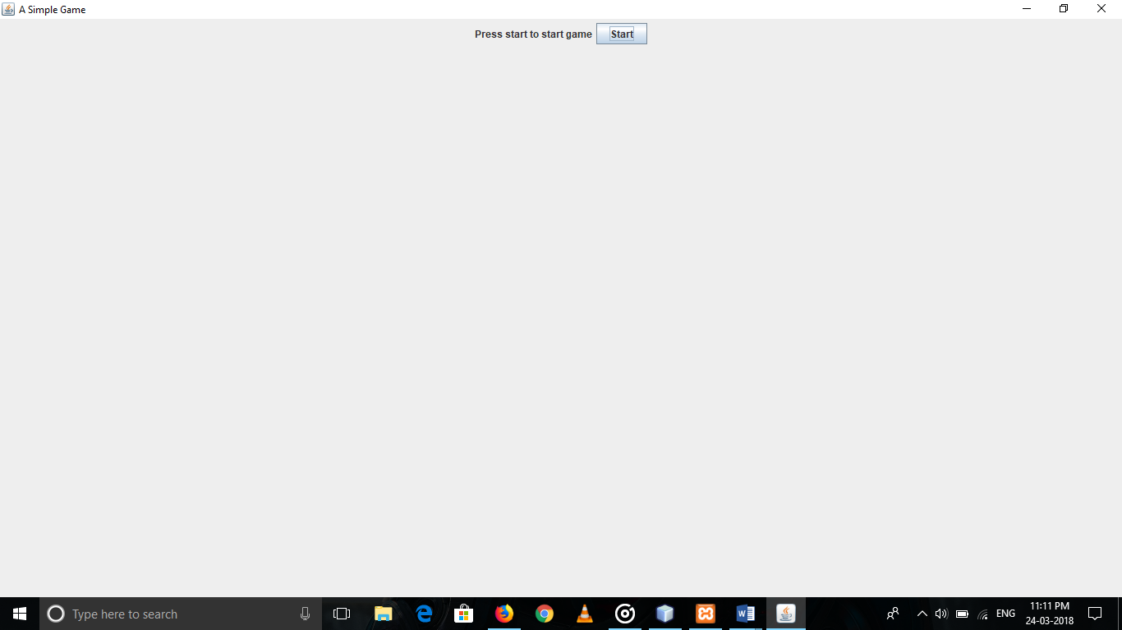

//Game screen after game has started

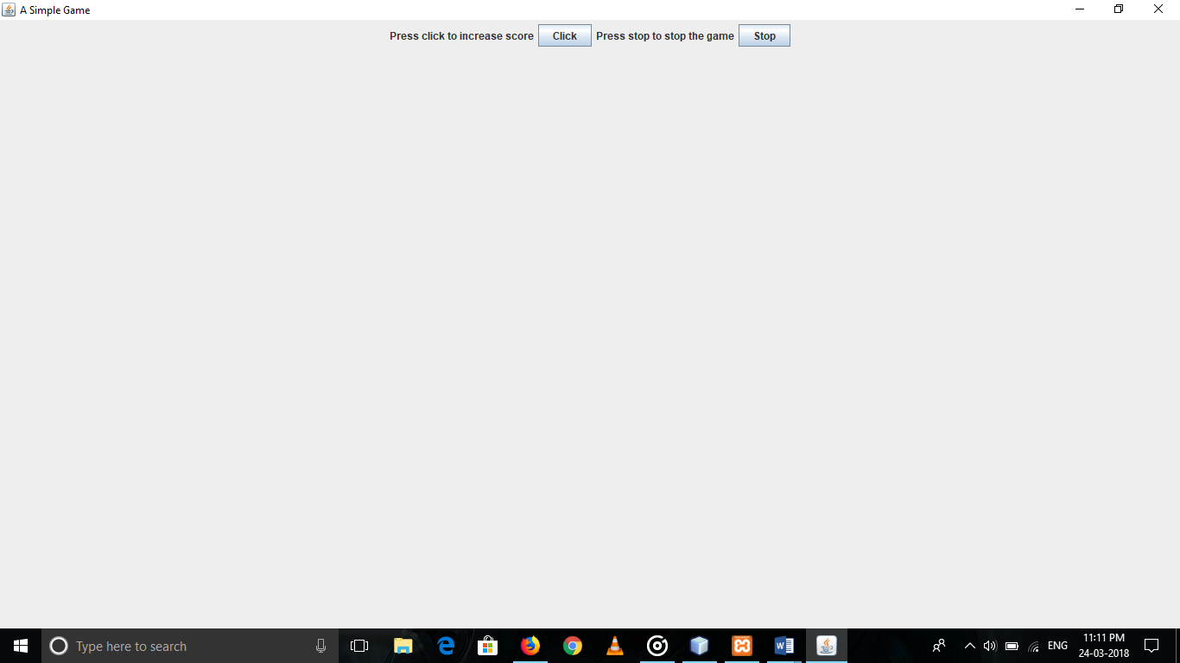

//Output of all scores on console

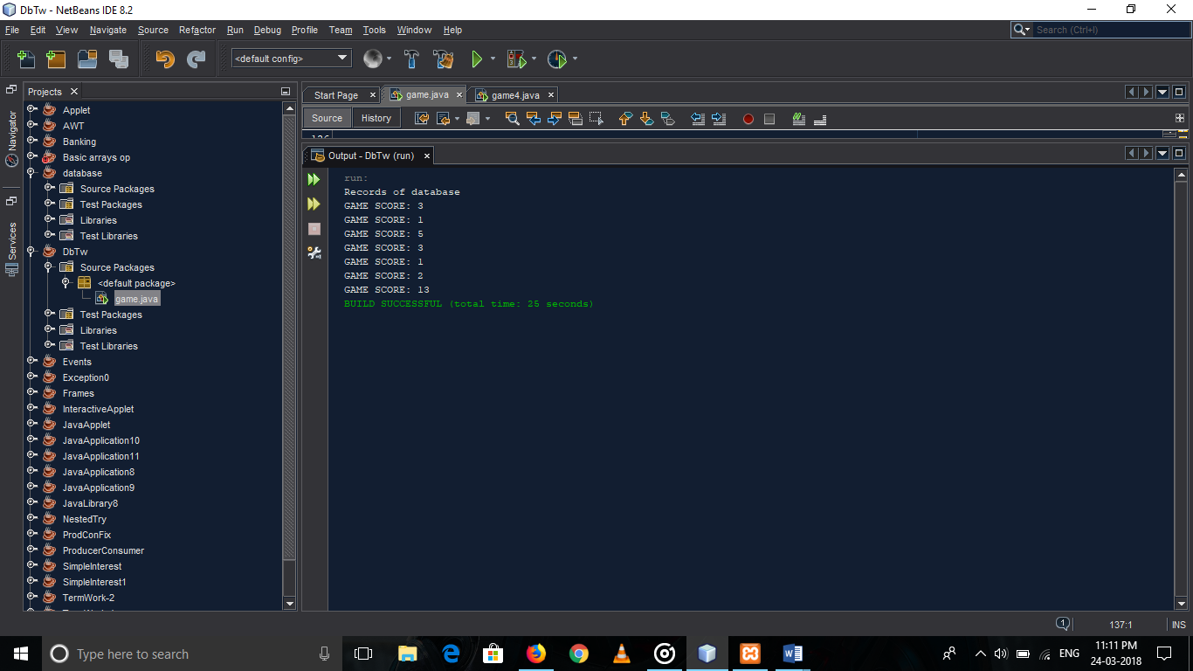

//Output of all scores in database

